TOPIC 2 : BRUTE FORCE
NAME: LAKSHMI DEVI. J
REG. NO: 192524300
1. Write a program to perform the following
An empty list
A list with one element
A list with all identical elements
A list with negative numbers

Aim
To write a Python program to sort the given list in ascending order and test it with different types of lists such as an empty list, a list with one element, identical elements, and negative numbers.

Algorithm
- Start the program.
- Create the input list.
- Use the sort() method to sort the list in ascending order.
- Display the sorted list.
- Stop the program.
Program
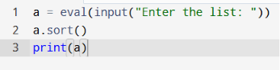
Output
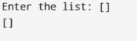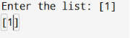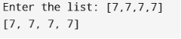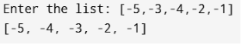
Time Complexity
O(n log n)
Space Complexity
O(n)

2. Describe the Selection Sort algorithm's process of sorting an array. Selection Sort works by dividing the array into a sorted and an unsorted region. Initially, the sorted region is empty, and the unsorted region contains all elements. The algorithm repeatedly selects the smallest element from the unsorted region and swaps it with the leftmost unsorted element, then moves the boundary of the sorted region one element to the right. Explain why Selection Sort is simple to understand and implement but is inefficient for large datasets. Provide examples to illustrate step-by-step how Selection Sort rearranges the elements into ascending order, ensuring clarity in your explanation of the algorithm's mechanics and effectiveness.

Aim
To sort an array in ascending order using the Selection Sort algorithm.
Pseudo Code
- Read the array.
- Find the smallest element in the unsorted part.
- Swap it with the current position.
- Repeat until the array is sorted.
- Print the sorted array.
Program
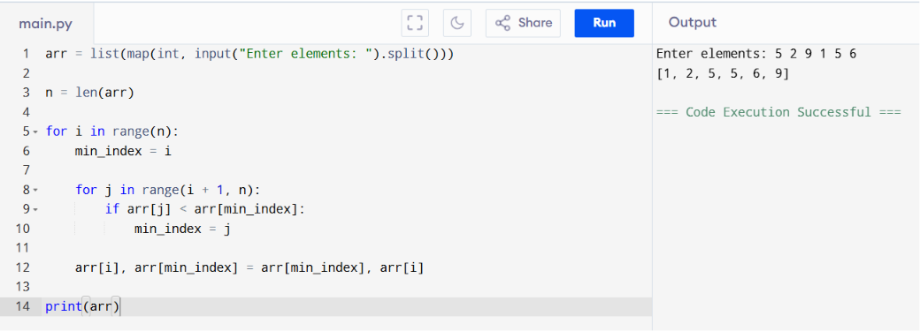
Time Complexity: O(n²)
Space Complexity: O(1)

3. Write code to modify bubble_sort function to stop early if the list becomes sorted before all passes are completed.

Aim
To sort an array using Bubble Sort and stop early if the array becomes sorted before all passes are completed.
Pseudo Code
- Read the array.
- Traverse the array.
- Compare adjacent elements and swap if necessary.
- If no swaps occur in a pass, stop the algorithm.
- Print the sorted array.
Program
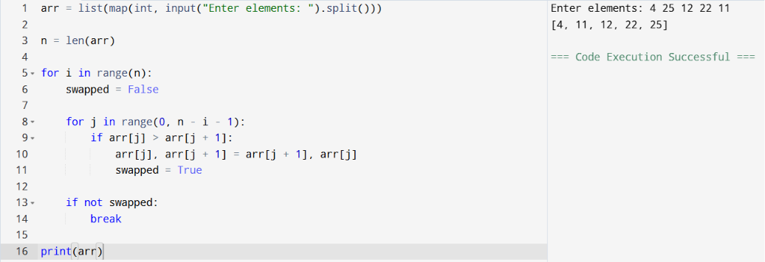
Time Complexity: O(n)
Space Complexity: O(1)

4. Write code for Insertion Sort that manages arrays with duplicate
elements during the sorting process. Ensure the algorithm's behavior
when encountering duplicate values, including whether it preserves the
relative order of duplicates and how it affects the overall sorting
outcome.
Aim
To sort an array containing duplicate elements using the Insertion Sort algorithm while preserving the relative order of duplicate elements.
Pseudo Code
- Read the array.
- Start from the second element.
- Compare the current element with previous elements.
- Shift larger elements one position to the right.
- Insert the current element in the correct position.
- Print the sorted array.
Program
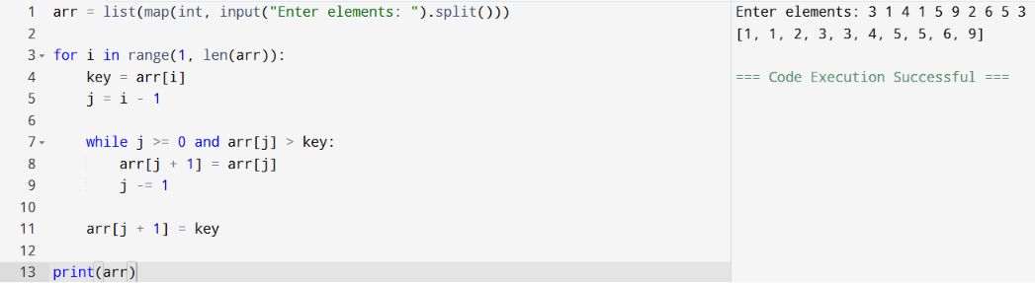
Time Complexity: O(n)
Space Complexity: O(1)

5. Given an array arr of positive integers sorted in a strictly increasing order, and an integer k. return the kth positive integer that is missing from this array.

Aim
To find the kth missing positive integer from a sorted array.
Pseudo Code
- Read the array and value of k.
- Start from positive integer 1.
- Compare each number with the array.
- Count missing numbers.
- When the kth missing number is found, print it.
Program
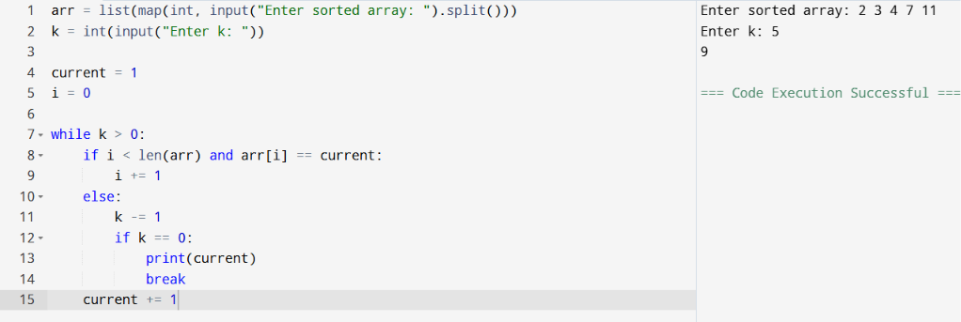
Time Complexity: O(n)
Space Complexity: O(1)

6. A peak element is an element that is strictly greater than its neighbors. Given a 0-indexed integer array nums, find a peak element, and return its index. If the array contains multiple peaks, return the index to any of the peaks. You may imagine that nums[-1] = nums[n] = -∞. In other words, an element is always considered to be strictly greater than a neighbor that is outside the array. You must write an algorithm that runs in O(log n) time.
Aim
To find the index of a peak element in an array using Binary Search.
Pseudo Code
- Read the array.
- Set low and high.
- Find the middle element.
- If middle element is smaller than the next element, search the right half.
- Otherwise, search the left half.
- Continue until low equals high.
- Print the index.
Program
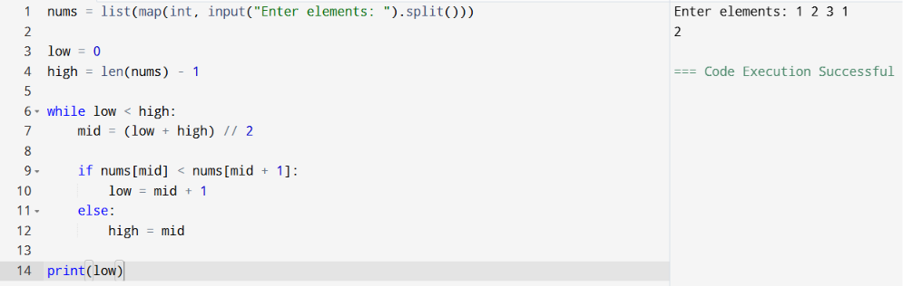
Time Complexity: O(log n)
Space Complexity: O(1)

7.Given two strings needle and haystack, return the index of the first occurrence of needle in haystack, or -1 if needle is not part of haystack.

Aim
To find the index of the first occurrence of the string needle in the string haystack.
Pseudo Code
- Read the haystack and needle strings.
- Traverse the haystack.
- Compare the substring with the needle.
- If found, print the index.
- Otherwise, print -1.
Program
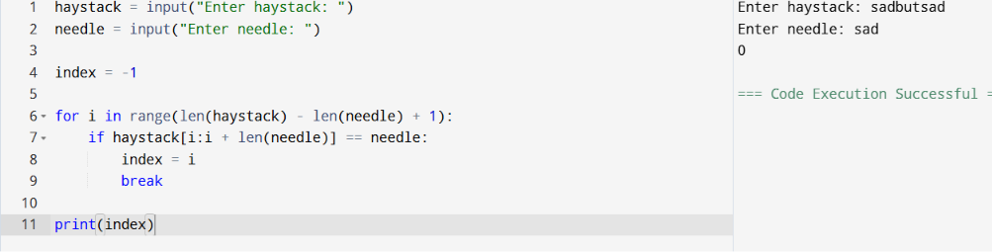
Time Complexity: O(n²)
Space Complexity: O(1)

8. Given an array of string words, return all strings in words that is a substring of another word. You can return the answer in any order. A substring is a contiguous sequence of characters within a string
Aim
To find all strings in the given list that are substrings of another string.
Pseudo Code
- Read the list of words.
- Compare every word with every other word.
- If one word is a substring of another, add it to the result.
- Print the result.
Program
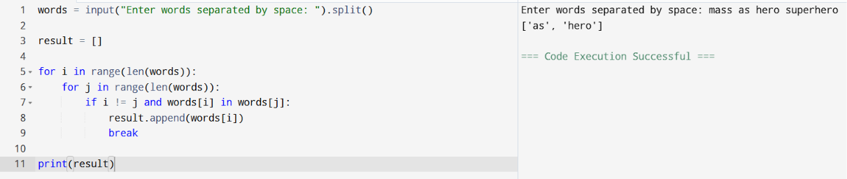
Time Complexity: O(n²)
Space Complexity: O(n)
9. Write a program that finds the closest pair of points in a set of 2D points using the brute force approach.
Aim
To find the closest pair of points in a set of 2D points using the brute-force approach.
Pseudo Code
- Read the points.
- Initialize the minimum distance.
- Compare every pair of points.
- Compute Euclidean distance.
- Update the closest pair if a smaller distance is found.
- Print the closest pair and minimum distance.
Program
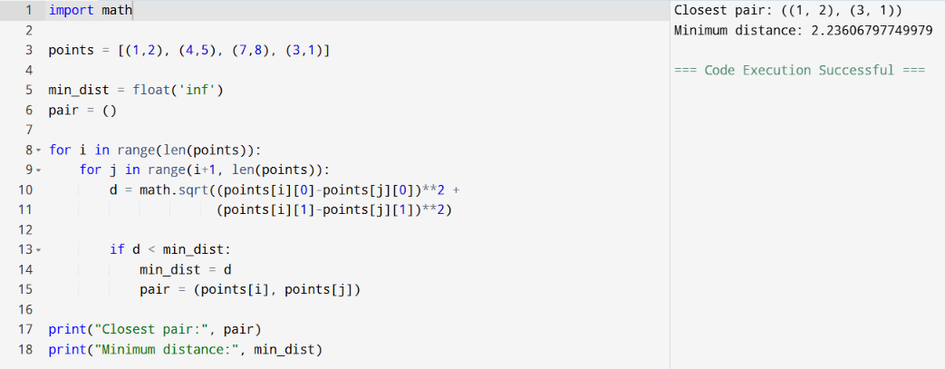
Time Complexity: O(n²)
Space Complexity: O(1)

10. Write a program to find the closest pair of points in a given set using the brute force approach. Analyze the time complexity of your implementation. Define a function to calculate the Euclidean distance between two points. Implement a function to find the closest pair of points using the brute force method. Test your program with a sample set of points and verify the correctness of your results. Analyze the time complexity of your implementation. Write a brute-force algorithm to solve the convex hull problem for the following set S of points? P1 (10,0)P2 (11,5)P3 (5, 3)P4 (9, 3.5)P5 (15, 3)P6 (12.5, 7)P7 (6, 6.5)P8 (7.5, 4.5). How do you modify your brute force algorithm to handle multiple points that are lying on the sameline?
Aim
To find the convex hull of a given set of points using the brute-force method.
Pseudo Code
- Read the set of points.
- For every pair of points, form a line.
- Check whether all other points lie on one side of the line.
- If yes, the pair belongs to the convex hull.
- Print the hull points.
Program
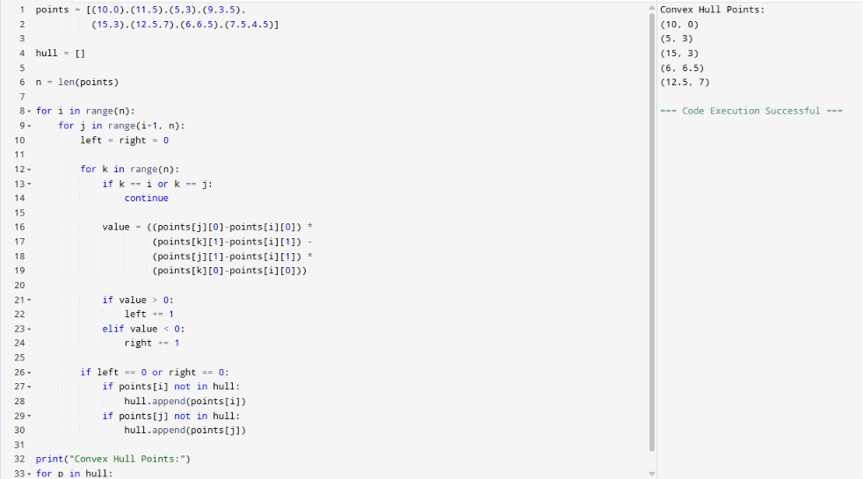
Time Complexity: O(n³)
Space Complexity: O(n)

11. Write a program that finds the convex hull of a set of 2D points using the brute force approach.
Aim
To find the convex hull of a set of 2D points using the brute force approach.
Pseudo Code
- Read the list of points.
- For every pair of points:
  - Form a line between them.
  - Check whether all other points lie on the same side of the line.
- If they do, add the pair to the convex hull.
- Remove duplicate points.
- Print the convex hull points.
Python Program
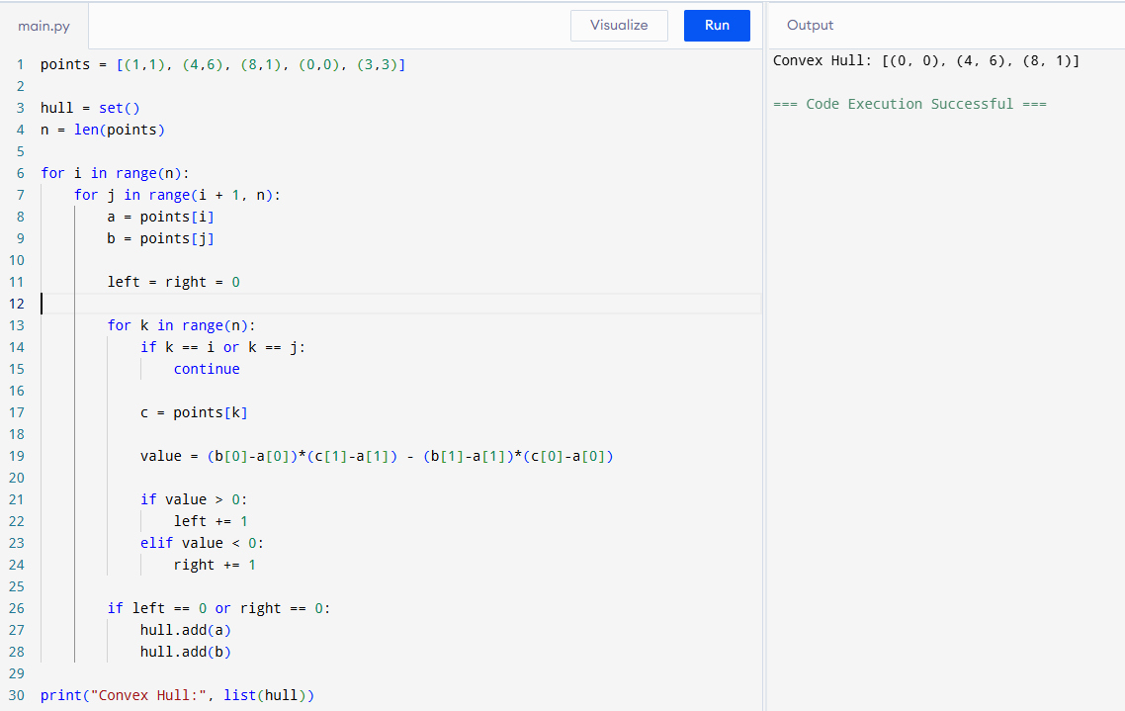
Time Complexity: O(n³)
Space Complexity: O(n)

12. You are given a list of cities represented by their coordinates. Develop a program that utilizes exhaustive search to solve the TSP. The program should:
1. Define a function distance(city1, city2) to calculate the distance between two cities (e.g., Euclidean distance).
2. Implement a function tsp(cities) that takes a list of cities as input and
performs the following:
• Generate all possible permutations of the cities (excluding the starting city) using itertools. permutations.

• For each permutation (representing a potential route):
• Calculate the total distance traveled by iterating through the path and summing the distances between consecutive cities.
• Keep track of the shortest distance encountered and the corresponding path.

• Return the minimum distance and the shortest path (including the starting city at the beginning and end).

3. Include test cases with different city configurations to demonstrate the program's functionality. Print the shortest distance and the corresponding path for each test case.

Aim
To find the shortest possible route that visits every city exactly once and returns to the starting city using exhaustive search.
Pseudo Code
- Read the coordinates of cities.
- Generate all permutations except the starting city.
- Calculate the total distance for each route.
- Keep track of the shortest route.
- Print the shortest distance and path.
Python Program
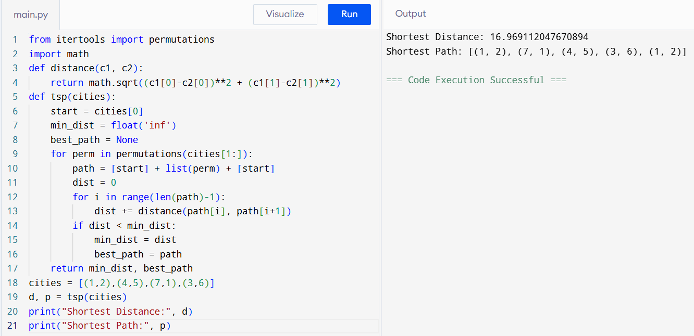
Time Complexity: O(n)
Space Complexity: O(n)
13. You are given a cost matrix where each element cost[i][j] represents the cost of assigning worker i to task j. Develop a program that utilizes exhaustive search to solve the assignment problem. The program should Define a function total_cost(assignment, cost_matrix) that takes an assignment (list representing worker-task pairings) and the cost matrix as input. It iterates through the assignment and calculates the total cost by summing the corresponding costs from the cost matrix Implement a function assignment_problem(cost_matrix) that takes the cost matrix as input and performs the following Generate all possible permutations of worker indices (excluding repetitions).
Aim
To find the minimum assignment cost of workers to tasks using exhaustive search.
Pseudo Code
- Read the cost matrix.
- Generate all task permutations.
- Calculate the total cost for each assignment.
- Store the assignment with the minimum cost.
- Print the optimal assignment and total cost.
Python Program
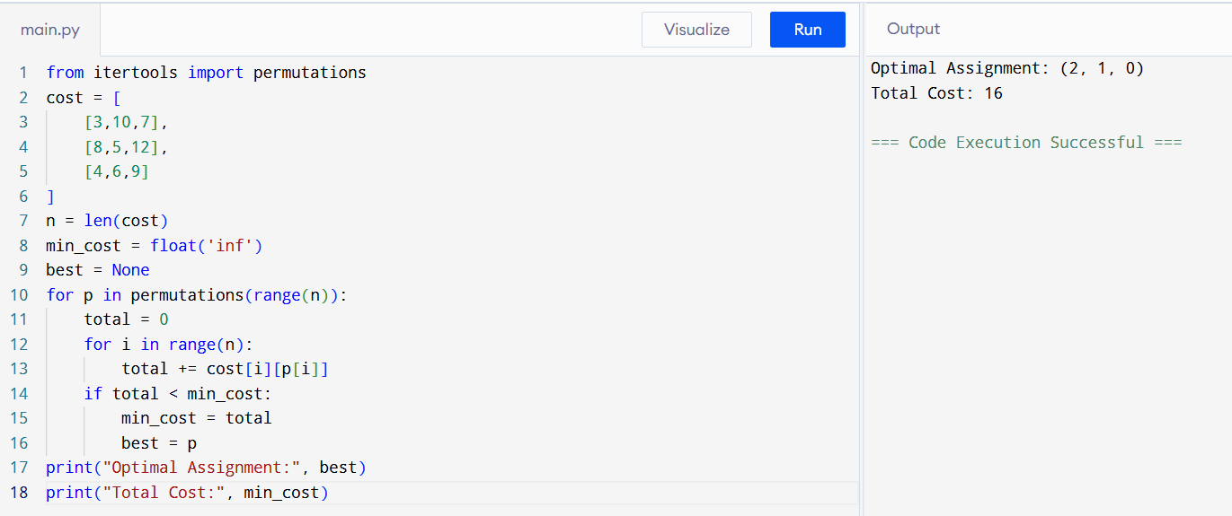
Time Complexity: O(n! × n)
Space Complexity: O(n)

14. You are given a list of items with their weights and values. Develop a program that utilizes exhaustive search to solve the 0-1 Knapsack Problem.
The program should:
Define a function total_value(items, values) that takes a list of selected items (represented by their indices) and the value list as input. It iterates through the selected items and calculates the total value by summing the corresponding values from the value list.
Define a function is_feasible(items, weights, capacity) that takes a list of selected items (represented by their indices), the weight list, and the
knapsack capacity as input. It checks if the total weight of the selected
items exceeds the capacity.
Aim
To find the optimal selection of items that maximizes the total value without exceeding the knapsack capacity.
Pseudo Code
- Read weights, values and capacity.
- Generate all possible subsets.
- Calculate total weight and value.
- Select the feasible subset with maximum value.
- Print the selected items and maximum value.
Python Program
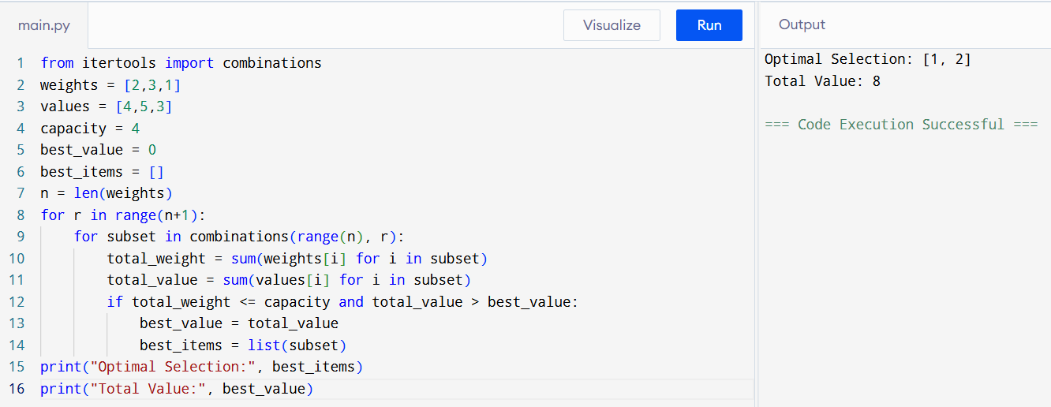
Time Complexity: O(2ⁿ)
Space Complexity: O(n)

